**Consider the below two tables**:

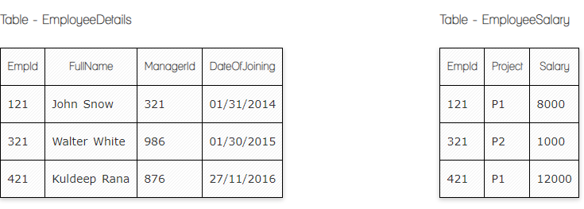

**Ques.1. Write a SQL query to fetch the count of employees working in project 'P1'.**

**Your Answer:**

**Select Count (EmpId), Project From EmployeeSalary Where Project='P1'**

**Ques.2. Write a SQL query to fetch employee names having salary greater than or equal to 5000 and less than or equal 10000.**

**Your Answer:**

**Select EmployeeDetails.FullName EmployeeSalary.Salary From EmployeeDetails Inner Join EmployeeSalary On EmployeeDetails.EmpId=EmployeeSalary.EmpId**

**Where EmployeeSalary.Salary Between 5000 And 10000**

**Ques.3. Write a SQL query to fetch count of employees sorted by project's count in descending order.**

**Your Answer:**

**Select Count (EmpId), Project From EmployeeSalary Group by Project Order by Count (Project) Desc**

**Ques.4. Write a query to fetch employee names and salary records. Return employee details even if the salary record is not present for the employee.**

**Your Answer:**

**Select EmployeeDetails.FullName EmployeeSalary.Salary From EmployeeDetails Left Join EmployeeSalary On EmployeeDetails.EmpId=EmployeSalary.EmpId**

**Ques.5. Write a SQL query to create an empty table with ‘Test’ name.**

**Your Answer:**

**Create Table Test (TestID int)**

**Ques.6. Write a SQL query to delete an empty table with ‘Test’ name.**

**Your Answer:**

**Drop Table Test**

**Ques.7. Write a SQL query to fetch all the Employees details from EmployeeDetails table who joined in Year 2016.**

**Your Answer:**

**Select * From EmployeeDetails Where DateOfJoining Like ‘%2016’**

**Ques.8. Write a SQL query to insert new record to the EmployeeDetails table with any data.**

**Your Answer:**

**Insert into EmployeeDetails (FullName, DateOfJoining) Values (‘John Rana’, ‘27/12/2016’)**

**Ques.9. Write a SQL query to update EmployeeSalery table with setting Salary to 2000 for Project P2.**

**Your Answer:**

**Update EmployeeSalary Set Salary=2000 Where Project=’P2’**

**Ques.10. Write a SQL query to right join both tables and draw the results.**

**Your Answer:**

**Select * From EmployeeDetails Right Join EmployeeSalary On EmployeeDetails.EmpId=EmployeeSalary.EmpI**

**Now take these two tables:**

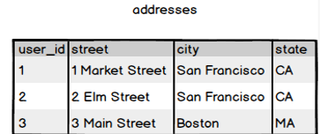

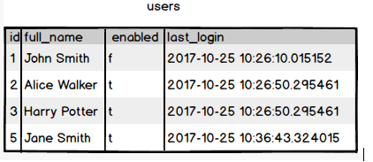

**Ques.11. Write a SQL query to fetch all users full_name from San Francisco.**

**Your Answer:**

**Select users.full_name, addresses.city From users Left Join addresses On users.id=addresses.user_id Where addresses.city=’San Francisco’**

**Ques.12. Write a SQL query to fetch all users full_name, last_login who are enabled**

**Your Answer:**

**Select full_name, last_login From users Where enabled='t'**

**Ques.13. Write a SQL query to fetch all users full_name who are not from Main street**

**Your Answer:**

**Select users.full_name, addresses.street From users Left Join addresses On users.id=addresses.user_id Where not addresses.street=’Main Street’**

**Ques.14. Write a SQL query to fetch all users full_name who are from Main street or San Francisco**

**Your Answer:**

**Select users.full_name, addresses.street, addresses.city From users Left Join addresses On users.id=addresses.user_id Where addresses.street=’Main Street’ Or addresses.city='San Francisco'**

**Ques.15. Write a SQL query to fetch user full_name who is equal to user_id from Boston (find user_id value in sub_query)**

**Your Answer:**

**Select full_name From users Where addresses.user_id In (Select user_id From addresses Where city='Boston')**